EXPERIMENT-6
6) Perform basic Image Handling and processing operations on the image is to read an image in python and Convert an Image to erode using Erode function.

a) CODE
import cv2
import numpy as np
img = cv2.imread("photo.jpg", 0)
kernel = np.ones((5, 5), np.uint8)
eroded = cv2.erode(img, kernel, iterations=1)
cv2.imwrite("eroded_image.jpg", eroded)
print("Image erosion completed successfully")

b) INPUT
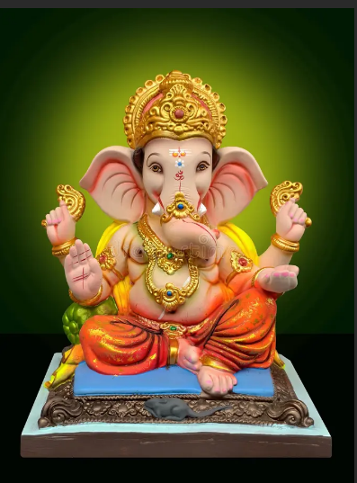
c) OUTPUT
